Abstract— Direction-of-Arrival (DoA) estimation is a key component of RF localization systems; however, performance is highly dependent on array geometry, environmental conditions, and algorithm selection. This research presents a hybrid antenna array system designed to estimate the azimuth, elevation, and range of a moving RF source using subspace-based DoA techniques. The system combines a vertical uniform linear array with either a circular or horizontal linear array configuration and processes received signals using the MUSIC and ESPRIT algorithms. These algorithms are implemented on the FMComms5/Zynq software-defined radio (SDR) platform. System performance was evaluated through Monte Carlo simulations as well as experimental testing with both static and moving RF sources. Results demonstrate that array geometry significantly influences estimation accuracy and snapshot requirements, while both algorithms provide stable DoA estimates under realistic indoor conditions. These findings highlight the practical advantages and limitations of hybrid antenna array configurations for real-time RF localization.
Keywords— Direction-of-Arrival (DoA), Azimuth, Elevation, localization, Uniform Linear Array (ULA), Uniform Circular Array (UCA), Signal to Noise Ratio (SNR), Root Mean Squared Error (RMSE)

INTRODUCTION
In recent years, unmanned aerial vehicles (UAVs) have become more common in commercial, industrial, and defense settings, which has increased interest in practical ways to track and locate them. Small UAVs can be difficult to detect and localize consistently because they may fly low, change direction quickly, and transmit relatively low-power RF signals, while optical sensors like LiDAR typically require the target to be within the sensor’s field of view and can be affected by clutter or multipath. This work presents a real-time RF localization prototype capable of estimating the azimuth, elevation, and range of a single static or moving 2.4 GHz RF source. Angular estimates are obtained using multi-element antenna arrays and subspace-based DoA algorithms, while range is measured using a mechanically steered LiDAR unit. Multiple array configurations, including ULA/UCA and orthogonal ULA/ULA arrangements, are evaluated alongside MUSIC and ESPRIT algorithms under consistent indoor test conditions. Performance is quantified using mean angular error and standard deviation across varying SNR levels and snapshot counts to determine the most accurate and stable configuration for single-source localization.

Project Objectives

The primary objective of this project is to develop a real-time radio frequency (RF) localization system capable of estimating the azimuth, elevation, and range of a single moving RF source. Angular localization (azimuth and elevation) is achieved through direction-of-arrival (DoA) estimation techniques, while range information is obtained using a LiDAR-based distance sensing system. The estimated angular coordinates are used to mechanically steer a pan-and-tilt LiDAR apparatus, enabling full localization in spherical coordinates (φ, θ, r).

To achieve angular estimation, multiple antenna array geometries are investigated, including Uniform Linear Array (ULA) and Uniform Circular Array (UCA) configurations. Hybrid array combinations consisting of ULA/UCA and orthogonal ULA/ULA arrangements are implemented to evaluate their suitability for two-dimensional DoA estimation.
In addition to hardware configuration comparisons, multiple subspace-based estimation algorithms are evaluated. These include Multiple Signal Classification (MUSIC) and Estimation of Signal Parameters via Rotational Invariance Techniques (ESPRIT). Performance is assessed under consistent indoor testing conditions using a single 2.4 GHz RF source.
Quantitative evaluation metrics include the mean angular error and standard deviation of azimuth and elevation estimates across Monte Carlo simulations and experimental trials. These metrics are used to determine the most accurate and stable array–algorithm configuration for single-source localization. The overall goal is to identify a system architecture that provides reliable, low-variance angular estimation suitable for real-time implementation.

Project Deliverables

The aim of this project is to deliever a real-time system that preforms DoA estimations for a single RF source. The demonstration displays azimuth and elevation estimates produced from the array processing chain and support end-to-end operation using the competition hardware stack. When integrated, the demonstration also includes LiDAR-based ranging driven by the DoA output to enable full (φ, θ, r) localization within the defined test environment.

Additional deliverables include documented software and hardware support packages to ensure reproducibility of results. These materials consist of MATLAB scripts, CAD drawings, configuration files, experimental datasets, and detailed setup instructions outlining required dependencies. A formal test procedure will be provided to define the experimental configuration, calibration steps, parameter settings, and evaluation metrics, enabling independent replication and validation of system performance. Supporting documentation will be included within this paper or provided as separate appendices for comprehensive analysis.

MATHEMATICAL BACKGROUND
This section develops the mathematical background for the subspace-based direction-of-arrival (DoA) estimation techniques evaluated in this study. Based on narrowband signal modeling, the derivations of the MUSIC and ESPRIT algorithms are presented, emphasizing their subspace decomposition principles and their applicability to the array geometries considered.

Multiple Signal Classification (MUSIC)

The MUSIC method is a widely used high-resolution, subspace-based method widely applied in array signal processing. As illustrated in Fig. 1, a far-field source impinging on a uniformly spaced antenna array produces time-shifted and phase-shifted measurements across the sensor elements. These spatial phase differences encode the incident direction of the source. MUSIC exploits the structure of the array covariance matrix to decompose the received data into orthogonal signal and noise subspaces.
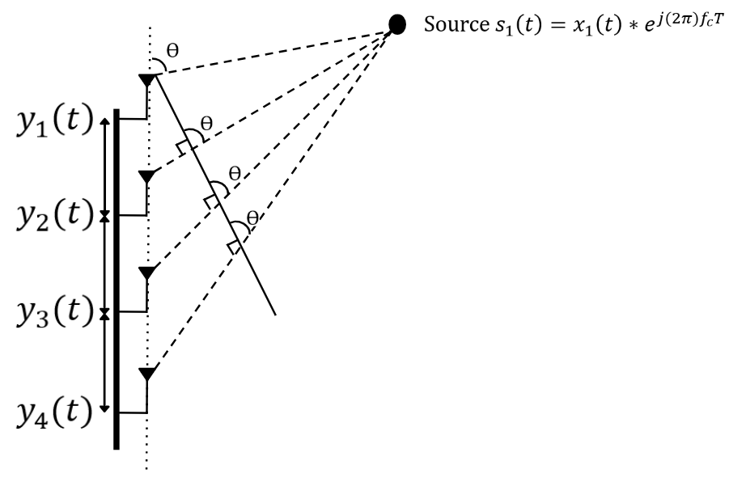
Fig 1. MUISC DoA Model with Source impinging on ULA

Due to the propagation delay between adjacent antenna’s, the incident wave produces progressive phase shifts across the array elements that depend on the angle of arrival 𝜃. The received array measurements at time 𝑡 can be expressed as a column vector whose entries correspond to the signals observed at each antenna element. Under the single-source assumption, the array output is modeled as the product of a direction-dependent steering vector and the transmitted signal, corrupted by additive noise. The received signal vector is therefore written as:

$$Recieved Values Steering Vector Noise Vector$$
$$Y\left(t\right) = A(Ө)*s_{1}(t) + N(t)$$
$$\left|\begin{matrix}y_{1}\left(t\right) \\ y_{2}\left(t\right) \\ y_{3}\left(t\right) \\ y_{4}\left(t\right)\end{matrix}\right| = \left|\begin{matrix}1 \\ e^{-jdksinӨ} \\ e^{-j2dksinӨ} \\ e^{-j3dksinӨ}\end{matrix}\right|x_{1}\left(t\right)*e^{j\left(2π\right)f_{c}T} + \left|\begin{matrix}N_{1}\left(t\right) \\ N_{2}\left(t\right) \\ N_{3}\left(t\right) \\ N_{4}\left(t\right)\end{matrix}\right|$$

After collecting 𝑁 time samples (snapshots) of the received vector y(t), the spatial information contained in the inter-element phase differences is captured through the sample covariance matrix. This covariance aggregates the cross-correlations between antenna channels and suppresses uncorrelated noise as the number of snapshots increases. The sample covariance is estimated as:

${\hat{R}}_{x}=\frac{1}{N}\sum_{n=1}^{N}{x\left[n\right]x^{H}[n]}=\frac{1}{N}XX^{H}$ (1)

MUSIC exploits the fact that, under the single-source model, ${\hat{R}}_{x}$ can be decomposed into a rank-one signal component plus a noise component. Eigenvalue decomposition separates these contributions by partitioning the eigenvectors into a signal subspace and a noise subspace:

${\hat{R}}_{x}=UΛU^{H}=[\begin{matrix}U_{S} & U_{N}\end{matrix}]\left[\begin{matrix}Λ_{S} & 0 \\ 0 & Λ_{N}\end{matrix}\right]{[\begin{matrix}U_{S} & U_{N}\end{matrix}]}^{H}$ (2)

A key result is that the true steering vector 𝑎(𝜃) lies in the signal subspace and is therefore orthogonal to the noise subspace. Consequently, when a candidate angle 𝜃 matches the true direction of arrival, the projection of 𝑎(𝜃) onto the noise eigenvector approaches zero. MUSIC converts this orthogonality condition into a pseudospectrum by evaluating the inverse of the steering vector’s projection onto the noise subspace, The DoA estimate is obtained by searching over 𝜃 and selecting the angle corresponding to the peak:

$P_{MUSIC}\left(θ\right)=\frac{1}{a^{H}\left(θ\right)U_{N}{U_{N}}^{H}a\left(θ\right)}$ (3)

The For a Uniform Circular Array (UCA), the MUSIC algorithm itself remains unchanged; however, the steering vector must be modified to reflect the circular geometry. Unlike the ULA, where phase shifts progress linearly along the array, each UCA element is positioned at a different angular location around a circle of radius 𝑅 As a result, the phase at each element depends on the projection of the incoming wave onto that element’s position.
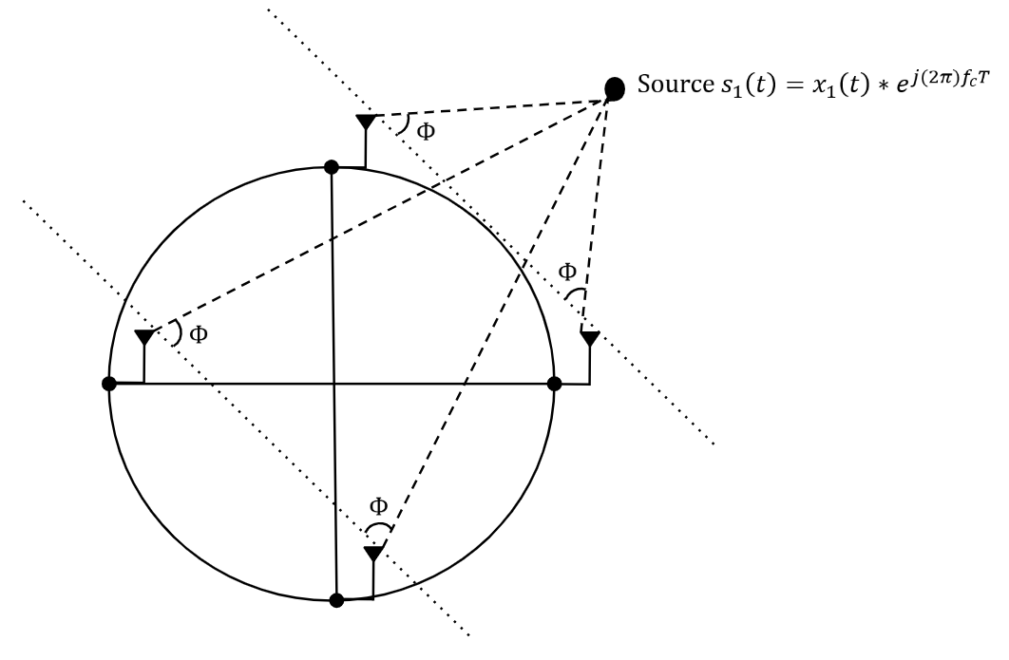
Fig 2. MUISC DoA Model with Source impinging on UCA

Estimation of Signal Parameters via Rotational Invariance Techniques (ESPRIT)

The Estimation of Signal Parameters via Rotational Invariance Techniques (ESPRIT) is a subspace-based DoA estimation method that exploits the translational symmetry of uniform linear arrays. As shown in Fig. 3, the four-element ULA is partitioned into two overlapping subarrays separated by a known spacing 𝑑. Because the incident wave produces a consistent phase progression across the array, the two subarrays observe signals that differ by a fixed phase rotation related to the angle of arrival 𝜃. ESPRIT leverages this rotational invariance within the signal subspace to directly compute the direction of arrival without requiring a spectral search.
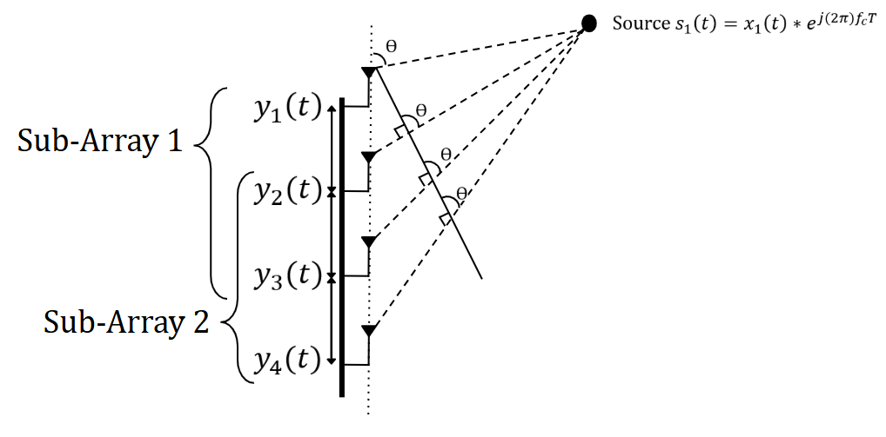
Fig 3. ESPRIT DoA Model with Source impinging on ULA

To exploit this array subspace symmetery, the signal subspace obtained from the covariance matrix ($E_{s}$) is multipled by the corresponding shifted arrays, creating the subspaces of Sub-Array 1 & 2, as seen in the equation below. the two subarrays share common elements and are separated by a known spacing 𝑑, the received signals in each subarray differ only by the phase shift induced by the incident plane wave. This relationship helps isolate the phase shift associated with the source DoA.

$E_{1}= J_{1}E_{s} E_{2}= J_{2}E_{s}$ (4)

Due to this shift invariance property, the phase difference between the separated signal subspaces contains the term kdsin($θ$) where k is the wave number. The eigenvalue associated with the subspace maintains the phase shift information, so the DoA estimation can be extracted from the eigenvalues using the equation below:

$\hat{θ}= \sin^{-1}(\frac{∆λ}{kd})$ (5)

SIMULATIONS
This section evaluates the practical performance of the proposed MUSIC and ESPRIT algorithms as implemented in this work. Monte Carlo simulations are conducted to assess robustness to noise and to model expected real-world performance. Two key parameters are analyzed: Signal-to-Noise Ratio (SNR) and number of snapshots, each evaluated with respect to DoA estimation accuracy. To ensure a fair and direct comparison, both algorithms are tested under identical simulation conditions, including array configuration, source characteristics, and noise realizations.

SNR vs, DoA Accuracy Monte Carlo Trails

The first Monte Carlo simulation evaluates the MUSIC algorithm’s immunity to noise. The elevation estimation using the ULA demonstrates strong robustness, maintaining low RMSE even at relatively low SNR values and converging to near-zero error at moderate to high SNR levels. In contrast, the azimuth estimation using the UCA exhibits a clear threshold behavior, with large estimation errors at low SNR due to poor signal and noise subspace separation. Once the SNR surpasses the threshold region, the azimuth error rapidly decreases and stabilizes. These results illustrate the inherent sensitivity of subspace-based methods to noise and highlight the influence of array geometry on estimation stability.

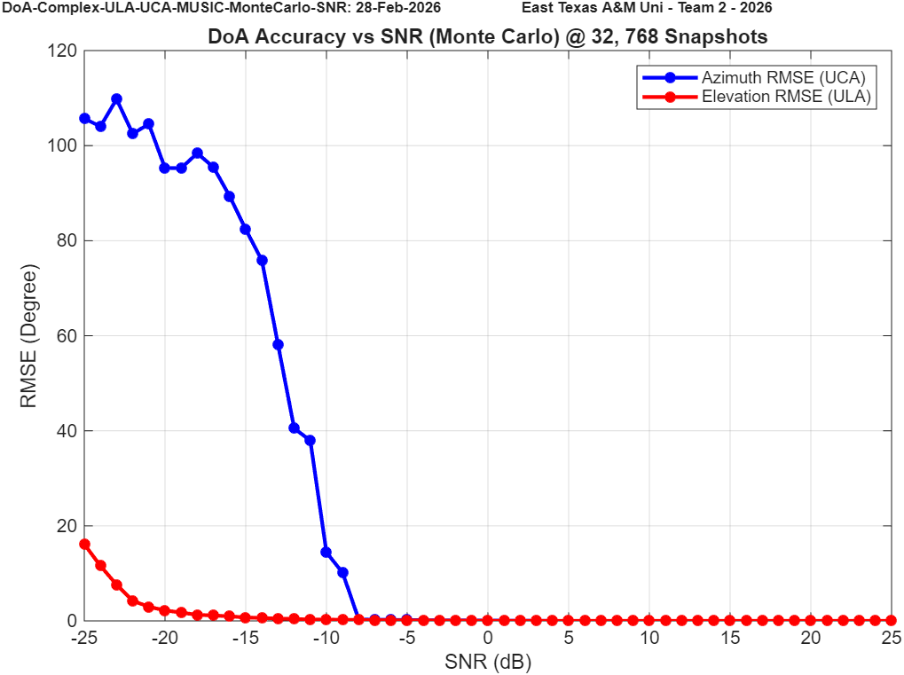
Fig 4. MUSIC ULA/UCA DoA SNR vs. Accuracy Simulation

Although ESPRIT was initially considered for both array configurations, it was not implemented for the ULA/UCA combination. The UCA does not inherently provide the required phase-shift invariance without additional transformations or virtual array mapping. Due to the limited number of elements and lack of directly paired phase-aligned subarrays for the configuration we have.

The second simulation evaluates the ESPRIT algorithm’s immunity to noise using the ULA/ULA configuration. The elevation estimation demonstrates strong robustness across the tested SNR range, maintaining relatively low error at reduced SNR and converging toward near-zero RMSE as SNR increases. Similarly, the azimuth estimation improved compared to the MUSIC simulations, meaning more reliable subspace separation and phase-shift extraction at moderate-to-high SNR values.

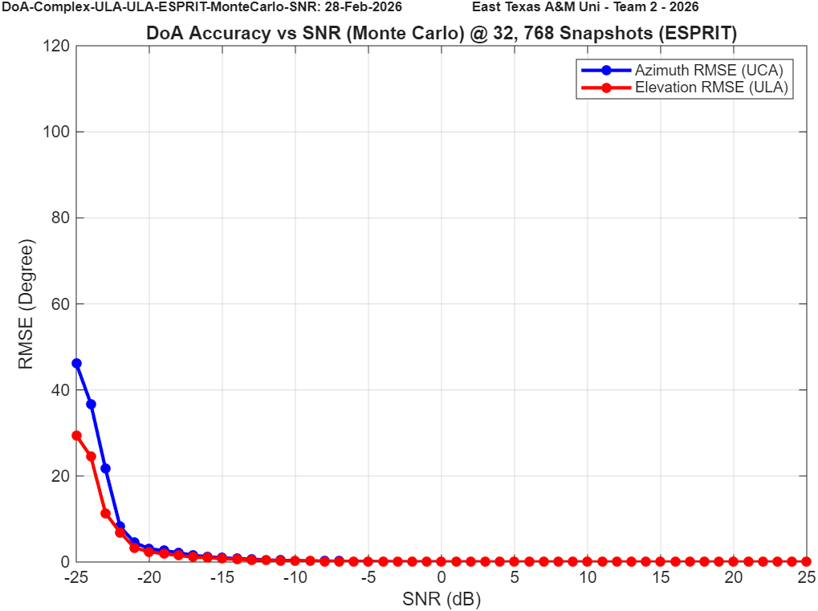
Fig 5. ESPRIT ULA/ULA DoA SNR vs. Accuracy Simulation

The final SNR vs. Accuracy simulation evaluates the MUSIC algorithm for the ULA/ULA configuration. Using the dual-linear array design provides improved SNR resilience, as the uniform linear geometry enhances the shift-invariant structure and stabilizes covariance estimation. As SNR increases, a clear separation between the signal and noise subspaces is observed, resulting in rapid convergence of the DoA estimates and reduced RMSE in both azimuth and elevation. These results demonstrate the robustness of the MUSIC algorithm when both array dimensions satisfy uniform linear structure.

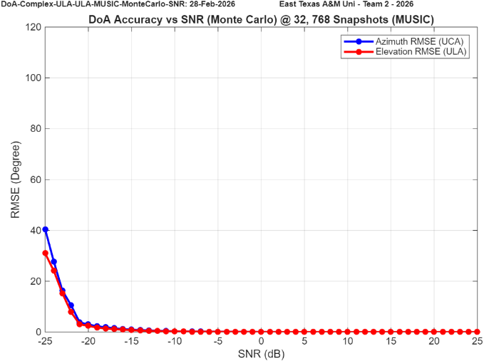
Fig 6. MUSIC ULA/ULA DoA SNR vs. Accuracy Simulation

Number of Snapshots vs. Accuracy

The second set of Monte Carlo simulations evaluates how well the MUSIC and ESPRIT algorithms perform when operating with a limited number of snapshots. Snapshot count directly affects subspace stability, since fewer samples reduce covariance accuracy and increase estimation variance, while larger snapshot sets improve signal and noise subspace separation at the cost of added computational time. This study helps us understand how efficient our algorithms can be in real-time operation without sacrificing estimation accuracy. The results first focus on the MUSIC algorithm under the ULA/UCA configuration to determine the minimum number of snapshots required to maintain stable azimuth and elevation estimates. This configuration stabilizes at around 2^11 = 2048 snapshots, so anything above that threshold should provide strong results.

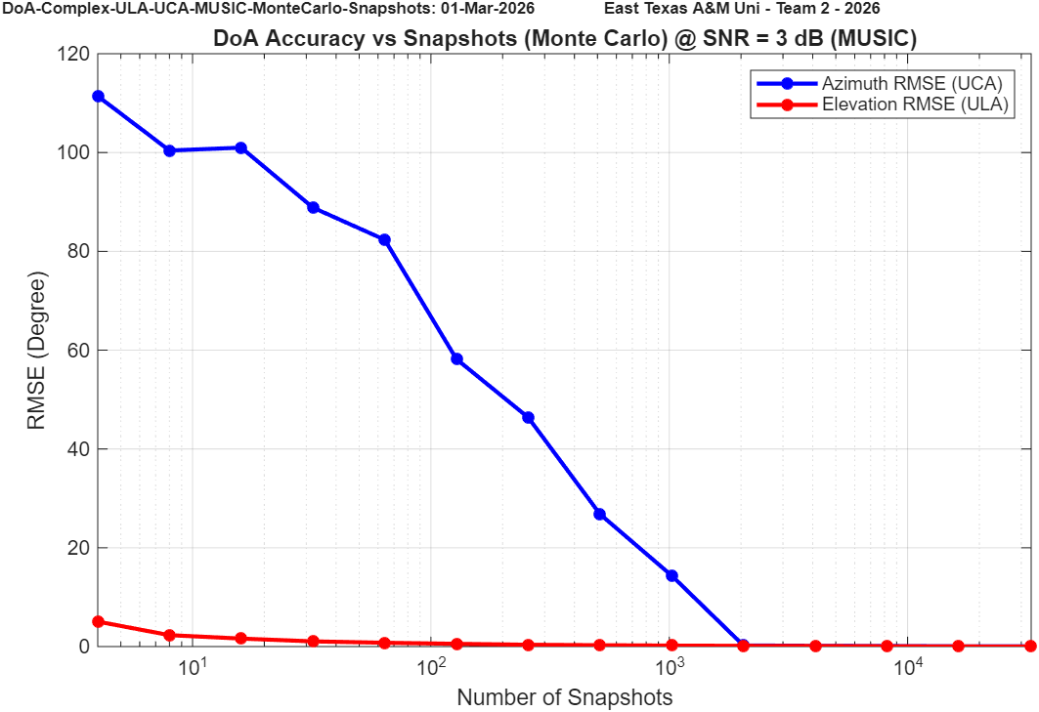
Fig 7. MUSIC ULA/UCA DoA Number of Snapshots vs. Accuracy Simulation

The second set of simulations evaluates the ESPRIT algorithm under the ULA/ULA configuration as the number of snapshots is varied. Unlike the MUSIC results, the ESPRIT implementation shows strong stability even at low snapshot counts, with both azimuth and elevation RMSE remaining near zero across the tested range. These results suggest that ESPRIT offers strong real-time efficiency in the dual-ULA configuration without requiring a large snapshot buffer to preserve estimation accuracy.

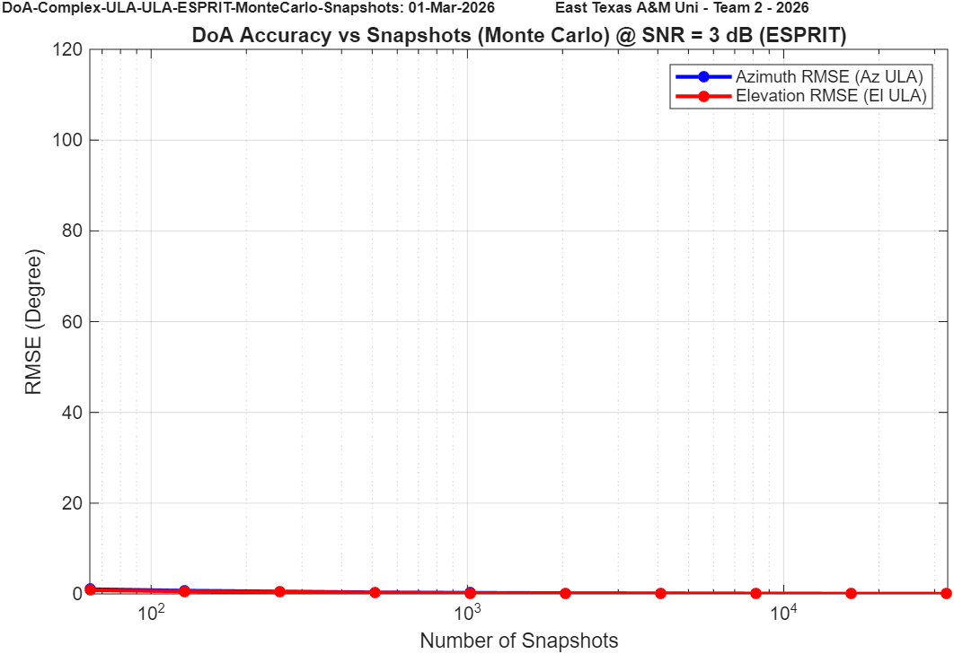
Fig 8. ESPRIT ULA/ULA DoA Number of Snapshots vs. Accuracy Simulation

The final set of results evaluates the MUSIC algorithm under the ULA/ULA configuration as the number of snapshots is varied. In this case, both azimuth and elevation estimation remain highly stable across the tested snapshot range, with RMSE values remaining near zero even at lower snapshot counts. Compared to the earlier ULA/UCA results, the dual-ULA geometry provides improved subspace consistency, resulting in stronger signal and noise space separation. These results suggest that array geometry has a greater impact on the required snapshot count than the choice of subspace algorithm. When the array structure satisfies uniform linear conditions in both dimensions, both MUSIC and ESPRIT maintain stable performance even with reduced covariance averaging.

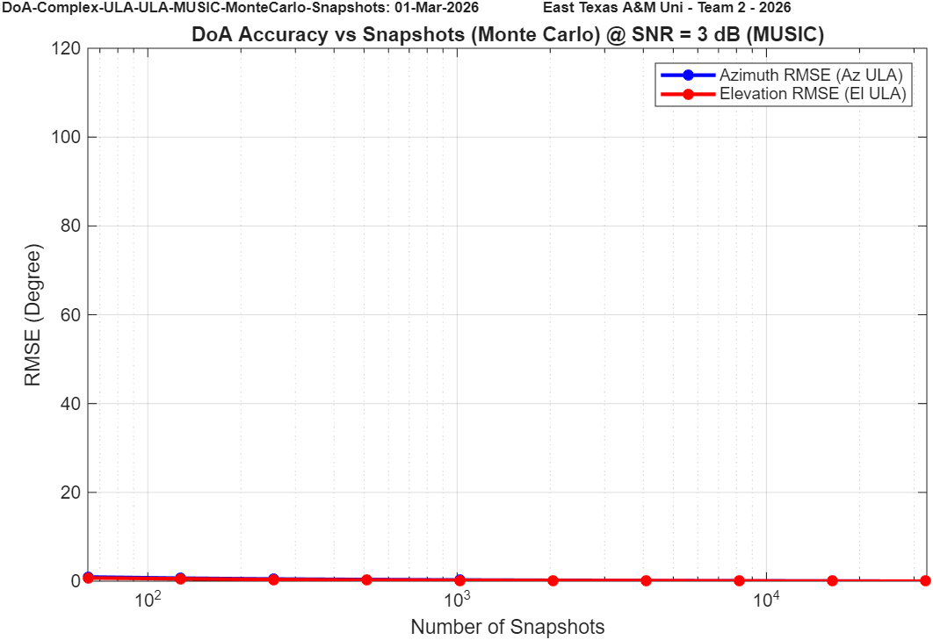
Fig 9. MUSIC ULA/ULA DoA Number of Snapshots vs. Accuracy Simulation

ANTENNA RADIATION PATTERN
One important aspect of evaluating the performance of the antenna array configurations is visualizing their radiation patterns. The radiation pattern describes the spatial sensitivity of the array and provides insight into how incoming signals are received from different directions. In this work, the MATLAB Antenna Toolbox is used to simulate and visualize the radiation characteristics of the array configurations.

UCA Pattern

The first radiation pattern examined is the uniform circular array (UCA). Although this array is primarily used for direction-of-arrival estimation in the azimuth plane, it is still important to evaluate the radiation characteristics in both azimuth and elevation. The overall radiation response determines the sensitivity of the array to signals arriving from different spatial directions. For example, if an RF source arrives from a direction corresponding to a radiation null in elevation, the received signal strength at the array may be significantly reduced, causing the signal to be dominated by noise and degrading the accuracy of the DoA estimation. As shown in Fig. 10, the “bell-pepper’ radiation pattern the circular array makes along with important azimuth nulls at 0, 90, 180 and 270 degrees.

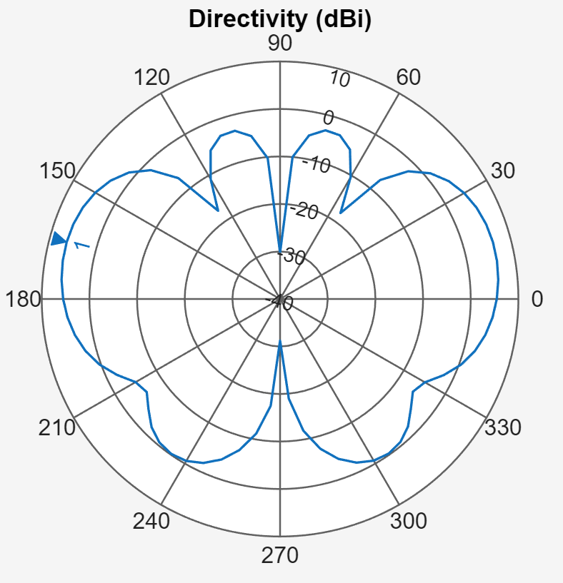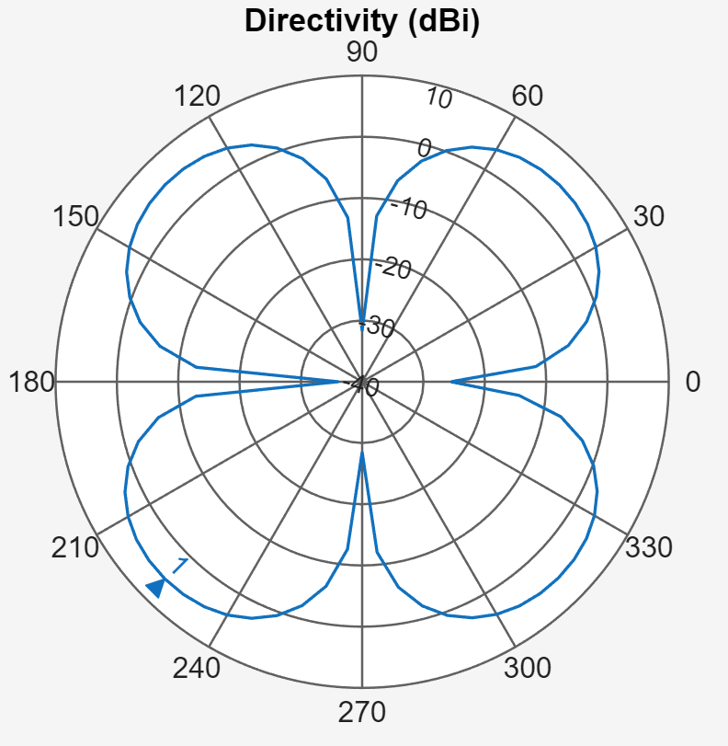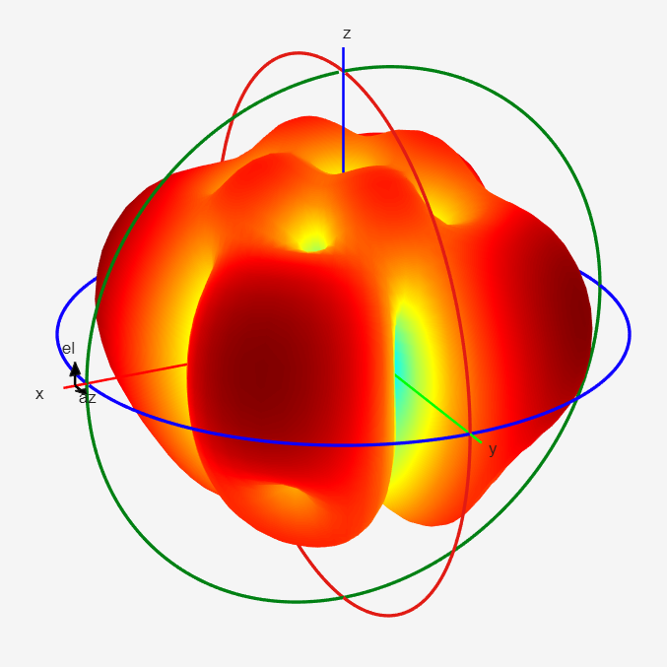
Fig 10. UCA Radiation Simulations with Elevation Plane (Left), Azimuth Plane (Right) & 3D Radiation

ULA Pattern

The second radiation pattern examined is the uniform linear array (ULA). Unlike the circular array, the ULA geometry produces a directional response primarily along the axis perpendicular to the array elements. As shown in Fig. 11, the radiation pattern is directly influenced by the spacing and phase relationships between the antenna elements, producing a dominant main lobe along with several sidelobes and nulls. This array design has strong response to the front and back of the array but poor performace on the sides of the array.

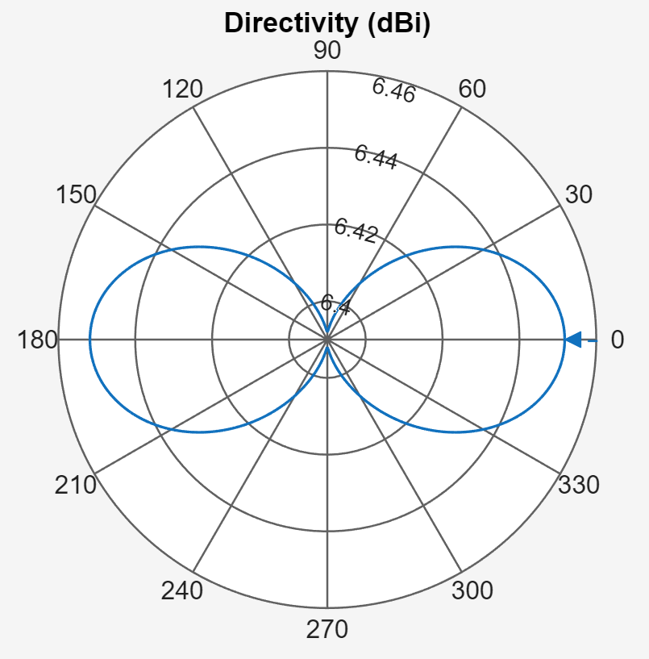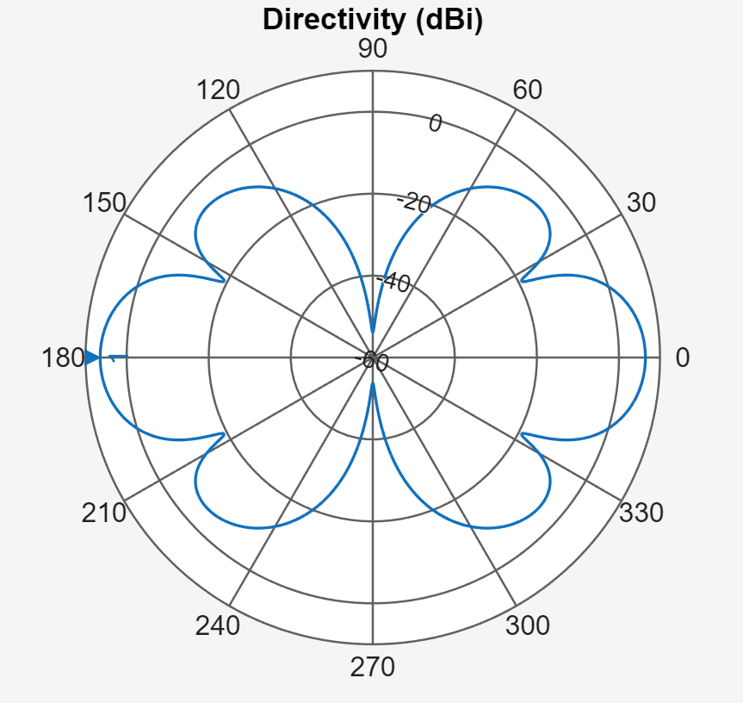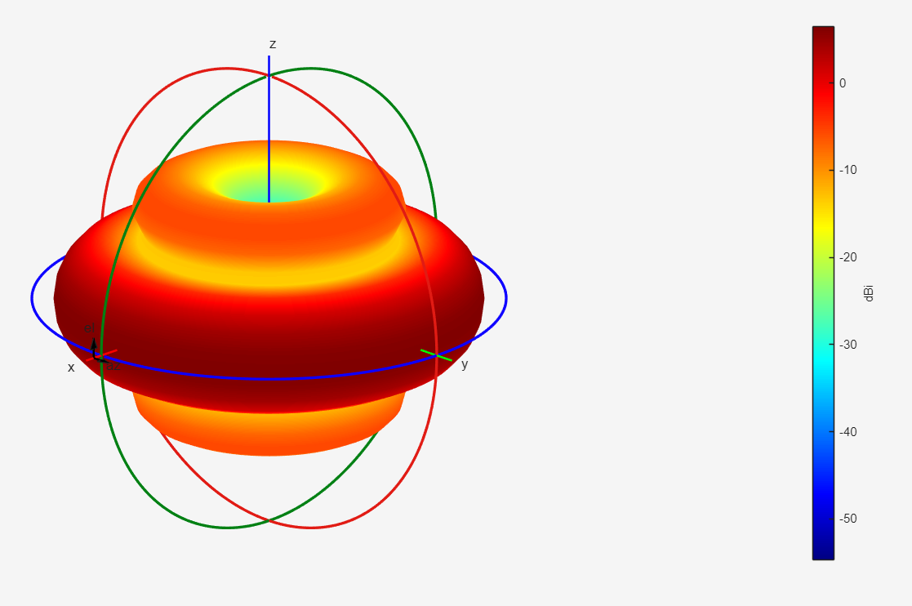
Fig 11. ULA Radiation Simulations with Elevation Plane (Left), Azimuth Plane (Right) & 3D Radiation

When the antenna elements are arranged in the ULA/UCA configuration, the resulting spatial response provides complementary directional characteristics in both azimuth and elevation. The circular array maintains a nearly uniform azimuth sensitivity, while the linear array introduces directional selectivity along the perpendicular axis. In contrast, the ULA/ULA configuration produces directional responses in both axes, resulting in stronger spatial selectivity but also introducing additional lobes and nulls in the combined radiation pattern. These characteristics highlight how the chosen array geometry influences the spatial coverage and potential blind directions of the system.

LIVE DEMO TESTING SET-UP
Our live demonstration platform is a fully operational Direction-of-Arrival (DoA) estimation system designed for real-time azimuth, elevation, and range tracking of an RF source. The physical setup consists of two orthogonally mounted four-element antenna arrays that enable independent angle estimation in both spatial dimensions. The azimuth array may be configured as either a Uniform Linear Array (ULA) or Uniform Circular Array (UCA), while the elevation array is implemented as a vertical ULA. Each array is connected to its own phase-synchronized FMComms5 + Zynq software-defined radio (SDR) platform, ensuring coherent multi-channel acquisition across all eight receive elements.
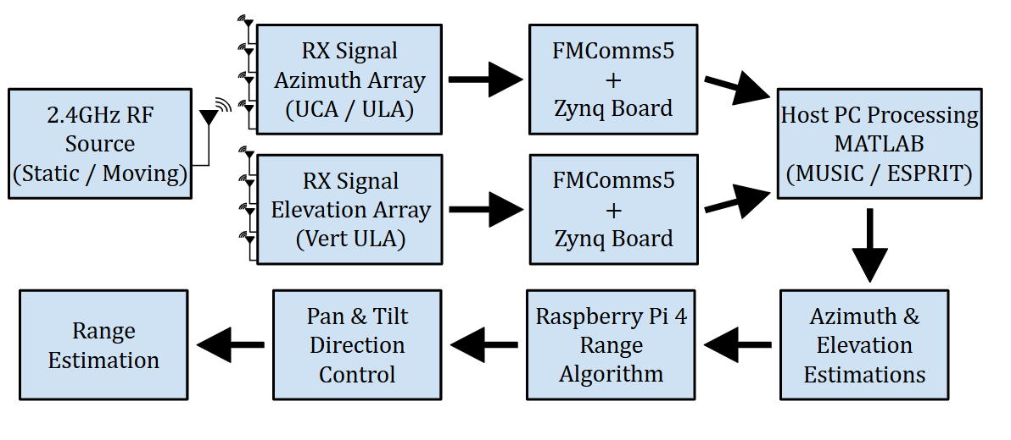
Fig 12. Real-Time Dual-Array Direction-of-Arrival Demo Architecture

The physical implementation directly mirrors the high-level architecture described above. The RF source consists of a USRP-2901 transceiver controlled by a Raspberry Pi 4, configured to transmit a continuous 2.4 GHz tone during testing. This compact transmission module provides a stable, low-profile, and easily repositioned source, allowing controlled static and dynamic movement throughout the test environment. The portability of the source enables repeatable angle verification and real-time tracking demonstrations without requiring large laboratory infrastructure.
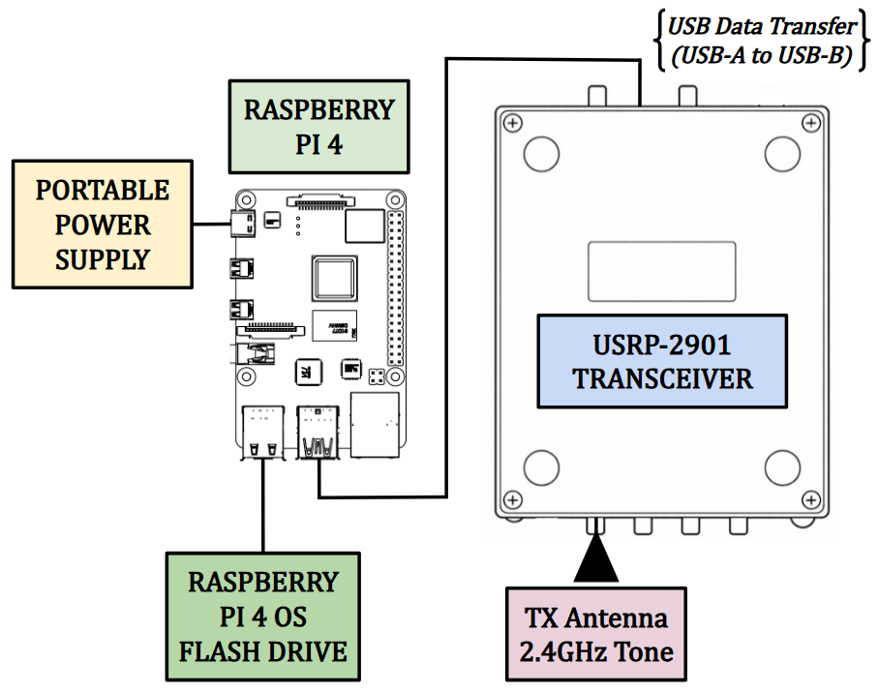
Fig 13. Live Demo Portable RF Source Testbed

RF Receiver Architecture

The most critical part of the hardware setup is the RF receiver system, which is responsible for capturing the emitted signal and computing the direction-of-arrival (DoA) estimation. The receiver architecture consists of three primary sections: the antenna array used to collect the incoming RF signal, the FMComms5/Zynq signal acquisition platform that performs RF downconversion and digitization, and a host PC where the DoA processing algorithms are executed in MATLAB. Two antenna configurations were implemented for testing: a UCA–ULA configuration for azimuth and elevation estimation (Fig. 14) and a dual ULA configuration used for comparison.
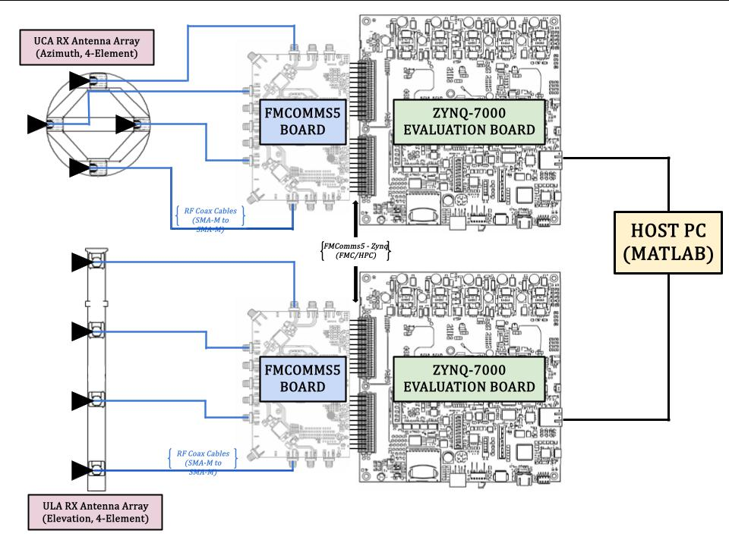
Fig 14. Live Demo RF Receiver Architecture (ULA/UCA)

Mechanical Range Architecture

After the azimuth and elevation estimations have been computed by the receiver system, the resulting directional information is transferred to the mechanical ranging subsystem to complete source localization. This subsystem consists of a Raspberry Pi controller, a pan–tilt servo platform, and a TF-02 LiDAR sensor used for distance measurement. The Raspberry Pi receives the estimated pointing angles from the host PC and commands the pan and tilt servos to orient the sensor toward the estimated direction of the RF source. Once aligned, the TF-02 LiDAR measures the distance to the target, allowing the system to estimate the full position of the emitter. The architecture of the mechanical range finding subsystem is shown in Fig. 15.
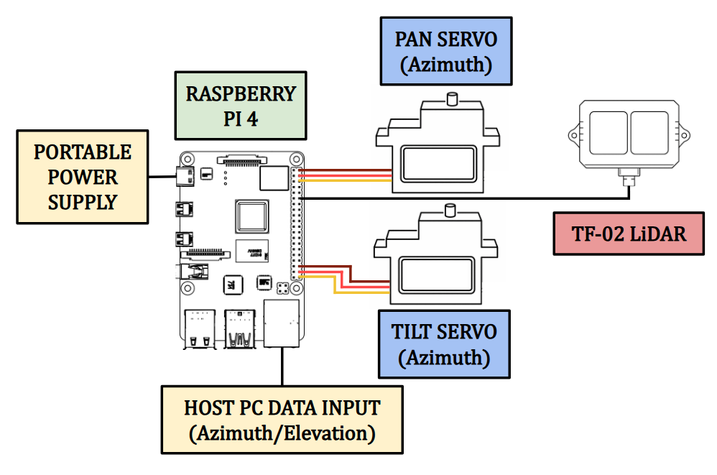
Fig 15. Live Demo Mechanical Range Finding Architecture

Complete Implementation

After completing the individual development of the emitter testbed, RF receiver subsystem, and LiDAR range-finding architecture, the final stage of the project is the integration of these components into a unified localization system. The figure below illustrates the complete system implementation, showing how each subsystem interacts to estimate the azimuth and elevation of the RF source before performing the final range measurement.

Starting with the emitter testbed (Fig. 13), shown in the top left of Fig. 16, a continuous 2.4 GHz waveform is generated by the Raspberry Pi 4 and transmitted through the USRP-2901 software-defined radio. This signal propagates through the surrounding environment and acts as the RF source used for the localization experiments.

Once the emitted signal is captured by the antenna array, in either the ULA/UCA or ULA/ULA configuration, the received RF signals are routed to the FMComms5/Zynq signal acquisition platform. The platform simultaneously samples each antenna channel while preserving the phase relationships between elements, which are required for accurate direction-of-arrival estimation. The digitized data is then processed using the implemented MUSIC and ESPRIT algorithms to estimate the azimuth and elevation angles of the incoming signal.

After the azimuth and elevation estimations are completed, the calculated directional information is transferred to the Raspberry Pi 4 to control the pan/tilt servo motors that position the LiDAR sensor. The LiDAR is then aligned with the estimated direction of arrival and performs a range measurement toward the RF source. By combining the angular estimates from the RF receiver with the distance measurement from the LiDAR sensor, the system is able to determine the spatial location of the emitter within the test environment.

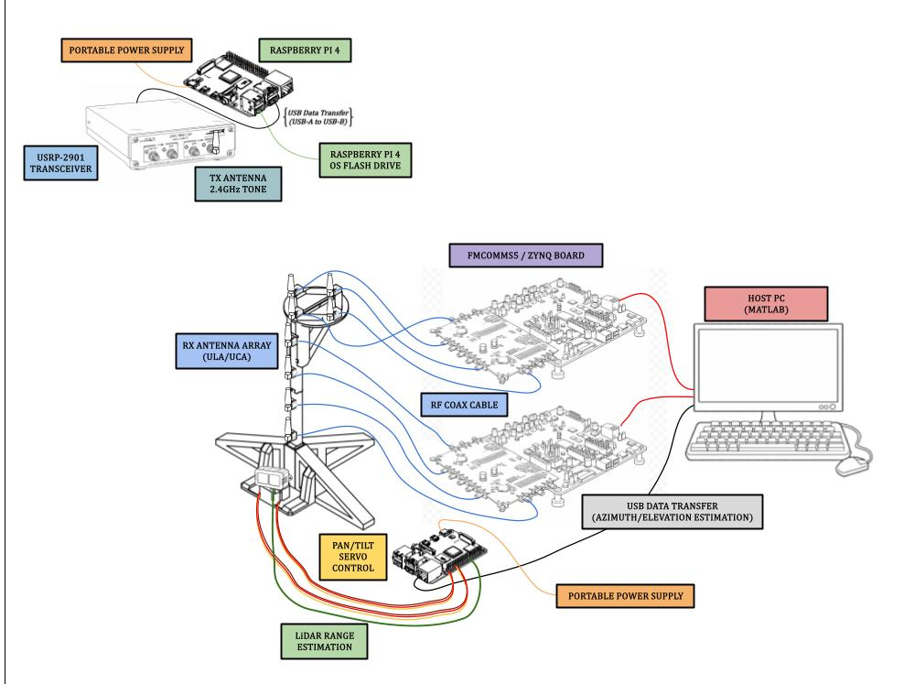
Fig 16. Live Demo Complete Implementation Visualization

Receiver Phase Synchronization
One of the most important factors in any DoA system is the phase synchronization of the receiver system. This system synchronization is achieved using the multi-chip synchronization capability of the FMComms5 boards, which contain dual AD9361 RF transceivers. This configuration ensures that the local oscillators, sampling clocks, and digital data paths across all receive channels start in a deterministic and phase-aligned state. As shown in the figure below, RF coaxial cables are connected from the TX channels to their respective RX channels during the phase synchronization process. A more detailed description of this procedure can be found in the appendices.
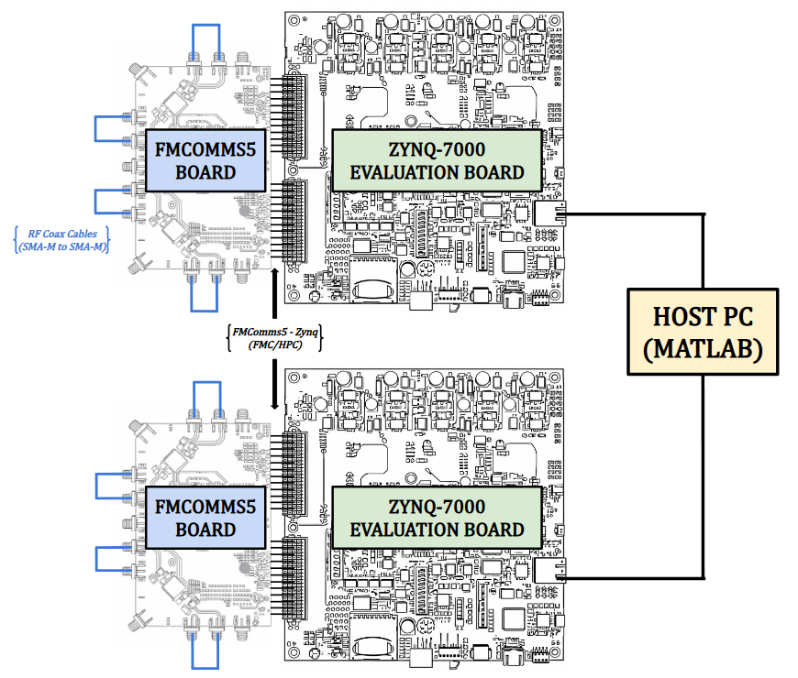
Fig 17. Receiver Phase Synchronization Set-Up

Testing Apparatus
The final phase of the demonstration setup focuses on accurately testing the system and collecting data for performance evaluation. Testing is conducted in two phases. The first phase evaluates the individual antenna array segments using both static and moving RF sources to verify that each array can independently estimate the appropriate angular component. The second phase integrates the arrays into either the ULA/UCA or ULA/ULA configuration to perform full azimuth and elevation DoA testing under both static and moving source conditions. Since the RF source must move in both azimuth and elevation in a semi-controlled manner, a dedicated testing apparatus was developed. This apparatus allows the RF transmitter to move along a pivoting axis, maintaining a constant radial distance from the antenna arrays as it sweeps through different azimuth angles. A pulley-based vertical adjustment system is also incorporated to vary the elevation of the transmitter while maintaining the same horizontal radius. Known angular positions and vertical heights are measured and recorded so that when the transmitter is placed at a static location, the estimated DoA results can be directly compared to the known azimuth and elevation angles for accuracy verification.

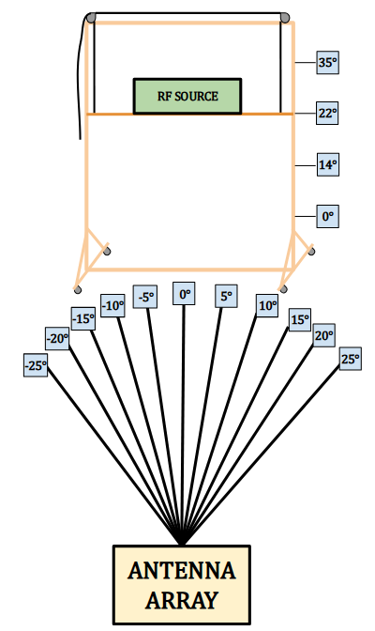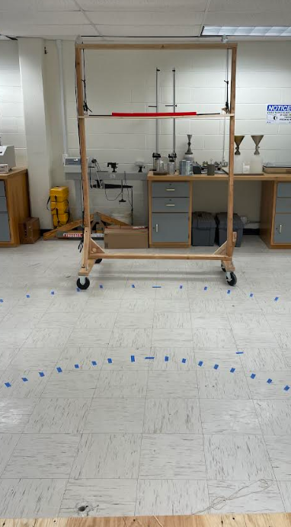
Fig 18. Live Demo Testing Apparatus

Using the apparatus described above, the proposed DoA system was experimentally tested to evaluate overall performance. During testing, two primary parameters were varied: the signal processing algorithm and the antenna array configuration. The MUSIC and ESPRIT algorithms were evaluated while operating with the ULA and UCA array configurations. Static testing was first conducted with the RF emitter positioned at known azimuth and elevation angles in order to establish a baseline for estimation accuracy. After static testing was completed, the same testing procedure was repeated with a moving RF source. During these moving tests, the emitter was only moved in the direction of interest; for example, during azimuth tests the elevation angle remained constant, and during elevation tests the azimuth angle remained fixed.

RESULTS AND OBSERVATIONS
Throughout this section, the collected estimation data is presented and analyzed for both static and moving RF sources. The results compare the performance of the MUSIC and ESPRIT algorithms across the different antenna array configurations tested during the live demonstration. Each configuration is evaluated based on the accuracy and consistency of the estimated direction of arrival and range measurements obtained during repeated trials. The moving source path is represented by either a linear or polynomial fit that accurately represents the path the source was moved.

Static Source Testing

The first moving source test evaluates the performance of the MUSIC algorithm using the UCA configuration. The test evaluates the RF source when placed at several fixed azimuth positions and the estimated DoA produced. The figure below shows the relationship between the true azimuth angle and the estimated azimuth for both outdoor and indoor environments, where the dashed diagonal line represents the ideal case in which the estimated DoA exactly matches the true source position. Many of the estimated values fall near this ideal line, indicating that the algorithm is generally able to track the source direction with reasonable accuracy. However, some spread in the measurements is present for repeated trials at the same source position, reflecting estimation variance caused by measurement noise and environmental effects
\ 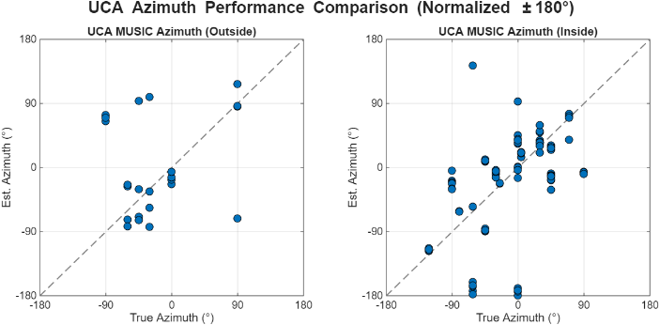
Fig 19. MUSIC-UCA Static DoA Estimation

The next set of static source testing evaluates the horizontal ULA performance while utilizing both the MUSIC and ESPRIT algorithms. These tests were conducted in the same manner as the UCA test, where the RF source was placed at several fixed azimuth positions and the estimated DoA produced by each algorithm was recorded. This test allows for a direct comparison of algorithm performance when operating under the same array geometry and environmental conditions. As shown in Fig. 20, the estimated azimuth values are plotted against the true source position, with the dashed diagonal line representing the ideal case where the estimated DoA exactly matches the true angle. While both algorithms generally follow the expected trend, noticeable spread in the measurements can be observed, indicating estimation variance caused by indoor multipath and measurement noise. Overall, the results highlight differences in estimation consistency between the MUSIC and ESPRIT algorithms when applied to the horizontal ULA configuration.
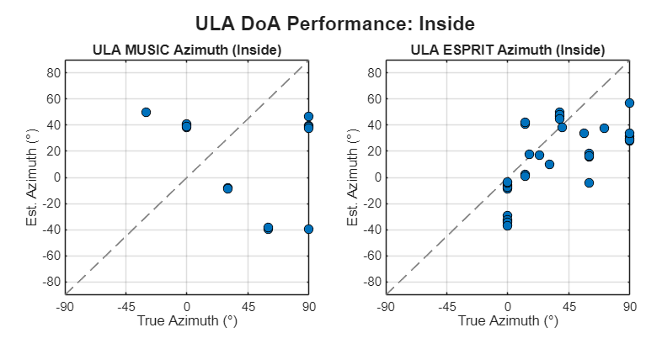
Fig 20. MUSIC/ESPRIT-ULA Static DoA Estimation
The final static test evaluates elevation estimation performance using the vertical ULA configuration while applying both the MUSIC and ESPRIT algorithms. Fig. 21 shows the estimated elevation angles compared to the true source elevation during indoor testing, where the dashed diagonal line represents the ideal case of perfect estimation. Both algorithms generally capture the trend of increasing elevation; however, noticeable deviation from the ideal line is present across several trials. The MUSIC results show greater spread in the estimated values, particularly at mid-range elevation angles, while the ESPRIT estimates appear slightly more clustered but still exhibit variance due to indoor multipath and measurement noise.

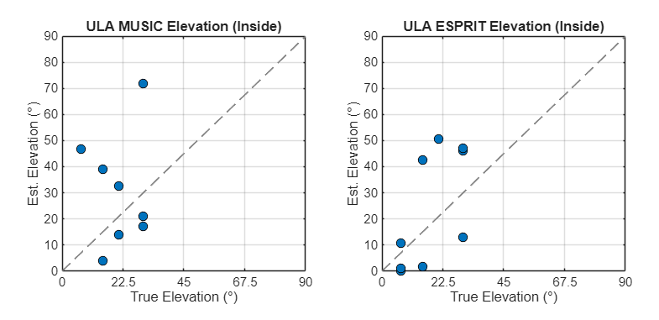
Fig 21. MUSIC/ESPRIT-ULA Static DoA Estimation

Moving Source Testing

The first moving source test evaluates the performance of the MUSIC algorithm using the UCA configuration. The test evaluates the system’s ability to track a dynamic RF emitter using the proposed DoA estimation methods. Two motion patterns were used during testing in order to observe system performance under different target trajectories. In the first test, the RF emitter was moved in a linear azimuth sweep while maintaining a constant elevation angle. In the second test, the emitter was moved in a complete circular motion across the azimuth range to evaluate how well the estimation algorithm responds to directional changes. The resulting DoA estimates for both motion patterns are shown in the figures below.
\
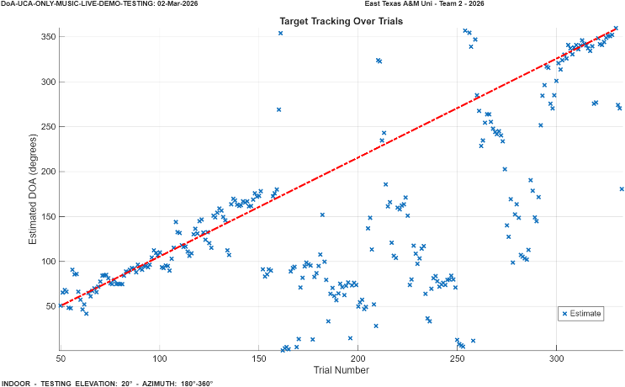
Fig 22. MUSIC-UCA Moving RF Source (Indoor)
Elevation: 20° Azimuth: 35°-130°

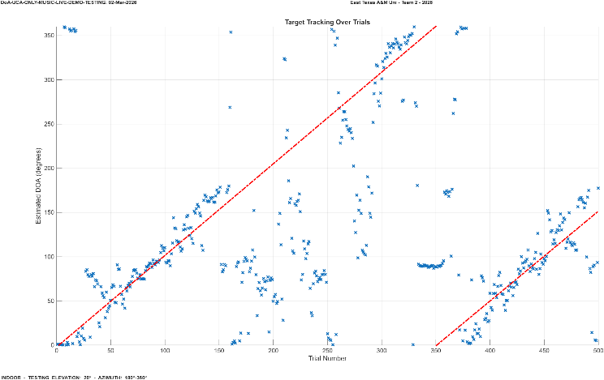
Fig 23. MUSIC-UCA Moving RF Source (Indoor)
Elevation: 15° Azimuth: 0°-360°-150°

The second moving source test evaluates the performance of the ESPRIT algorithm while using the ULA configuration. During this test, the RF source was moved very in the same general pattern as the MUSIC where in the first test, the RF emitter was moved in a linear azimuth sweep while maintaining a constant elevation angle. In the second test, the emitter was moved in a back-and-forth motion across the azimuth range to evaluate how well the estimation algorithm responds to directional changes. The resulting DoA estimates for both motion patterns are shown in the figures below.

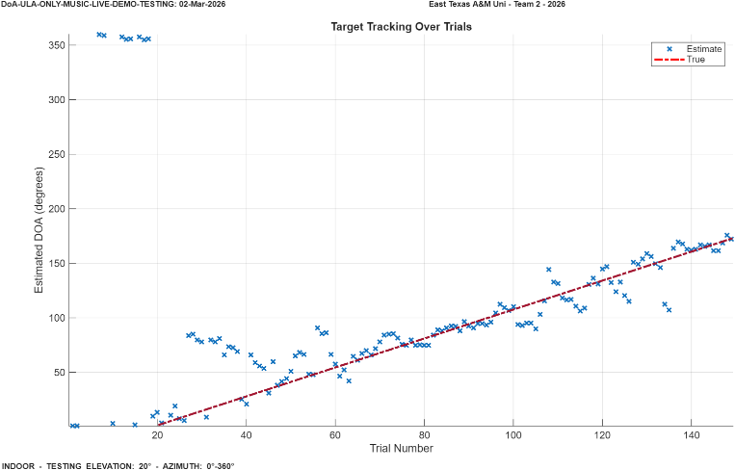
Fig 24. ESPRIT-ULA Moving RF Source (Indoor)
Elevation: 20° Azimuth: 0°-165°

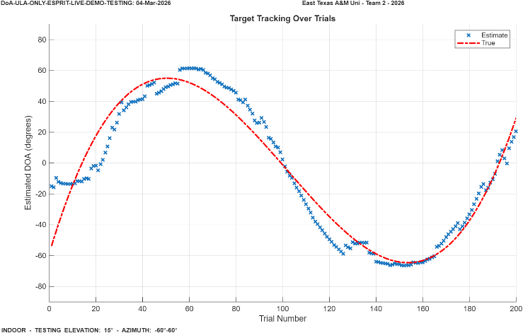
Fig 25. ESPRIT-ULA Moving RF Source (Indoor)
Elevation: 15° Azimuth:-60°-60°

The final moving source tests evaluate the performance of the vertical ULA configuration. During these tests, the RF source was moved along the same general paths used in the previous experiments. The first test consisted of a linear sweep where the elevation angle of the source was varied while the azimuth remained constant. Following this, a second test was performed in which the source was moved in a back-and-forth motion across the elevation range in order to evaluate the system’s ability to track changes in elevation direction. The resulting DoA estimates for both motion patterns are shown in the figures below.

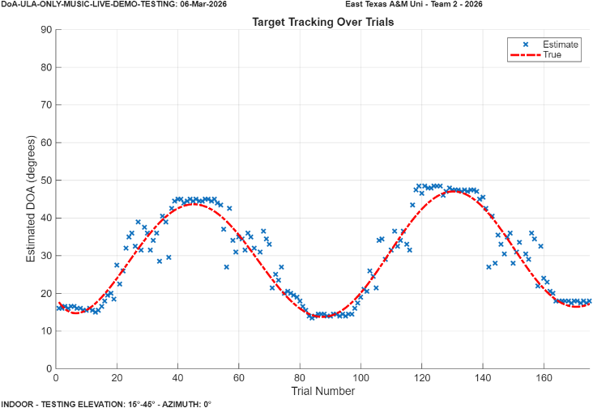
Fig 26. MUSIC-ULA Moving RF Source (Indoor)
Elevation: 15°-45° Azimuth: 0°

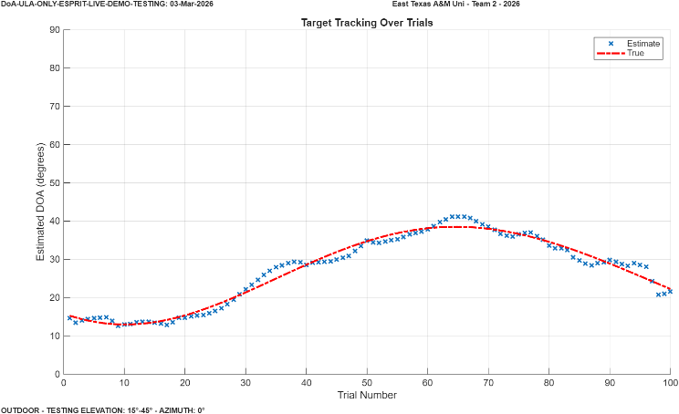
Fig 27. ESPRIT-ULA Moving RF Source (Indoor)
Elevation: 15°-40° Azimuth: 0°

CONCLUSION
This work presented the design and implementation of a fully functioning hybrid RF localization system capable of estimating the azimuth, elevation and range of a since moving RF source. Combining subspace-based Direction-of-Arrival (DoA) algorithms with multi-array antenna designs and LiDAR based range finding provided new and important evaluations of how array geometry can affect capability. Two antenna geometries were investigated, including a uniform circular array (UCA) for azimuth estimation and uniform linear arrays (ULA) for elevation estimation. The MUSIC and ESPRIT algorithms were evaluated through Monte Carlo simulations and experimental testing to determine their performance under varying signal conditions.
Simulation and experimental results demonstrated that both algorithms are capable of accurately estimating DoA when sufficient signal quality and snapshot counts are available. The UCA configuration provided reliable azimuth estimation, while the ULA structures enabled effective elevation estimation. Experimental testing with static and moving RF sources confirmed that the system can track target motion and produce stable DoA estimates in an indoor environment where multipath effects were present. By combining RF-based angular estimation with LiDAR range measurements, the system successfully demonstrated the ability to perform full spatial localization of an RF emitter.
Future work could focus on improving robustness to noise and multipath across different environments, increasing the number of elements per array, exploring additional array geometries, and enabling localization of multiple RF sources simultaneously. These improvements would further enhance the system’s capability and applicability to real-world RF applications such as spectrum monitoring, emitter tracking, and electronic warfare.

ACKNOWLEDGEMENTS
We would like to thank the Air Force Research Laboratory (AFRL) and the Wright Brothers Institute (WBI) for hosting and supporting the AFRL SDR University Challenge, and for providing the competition structure, technical feedback opportunities, and an evaluation venue for the project demonstration. We would also acknowledge East Texas A&M University (ETAMU) for institutional support and resources that enabled development and testing of the prototype system. Appreciation is extended to the project’s faculty advisor(s), technical mentors, and laboratory staff for guidance on RF hardware integration, calibration practices, and experimental methodology. Additional thanks are given to the challenge sponsors and tool providers who supported the program and student teams through hardware and software resources, including organizations such as MathWorks and National Instruments, as applicable to the competition year.

References
- Codău, C.; Buta, R.-C.; Păstrăv, A.; Dolea, P.; Palade, T.; Puschita, E. Experimental Evaluation of an SDR-Based UAV Localization System. Sensors 2024, 24, 2789. https://doi.org/10.3390/s24092789
- H. -C. Chen, T. -H. Lin, H. T. Kung, C. -K. Lin and Y. Gwon, "Determining RF angle of arrival using COTS antenna arrays: A field evaluation," MILCOM 2012 - 2012 IEEE Military Communications Conference, Orlando, FL, USA, 2012, pp. 1-6,
doi: 10.1109/MILCOM.2012.6415851
- O. A. Oumar, M. F. Siyau and T. P. Sattar, "Comparison between MUSIC and ESPRIT direction of arrival estimation algorithms for wireless communication systems," The First International Conference on Future Generation Communication Technologies, London, UK, 2012, pp. 99-103, doi: 10.1109/FGCT.2012.64765631
- https://wiki.analog.com/_media/resources/tools-software/linux-software/doa_whitepaper.pdf
- M. A. ihedrane, A. E. FAdl, and S. Bri, “Direction of Arrival Using 2-D Matrix Pencil Method,” Advances in Science, Technology and Engineering Systems Journal, vol. 4, no. 5, pp. 341–342, 2019, doi: https://doi.org/10.25046/aj040544.
- ‌Cristian Codău, R.-C. Buta, A. Păstrăv, P. Dolea, Tudor Palade, and E. Puschita, “Experimental Evaluation of an SDR-Based UAV Localization System,” Sensors, vol. 24, no. 9, pp. 2789–2789, Apr. 2024, doi: https://doi.org/10.3390/s24092789.

